# The fate of organic pollutants in the subsurface and groundwater at the field scale during storms and irrigation events

Shulamit Nussboim, Lea Wittenberg, Elazar Volk, Jonathan B. Laronne, Felicia Orah Rein

## Appended material

## Research data is available at the bottom. Link to [original files and codes](https://drive.google.com/drive/folders/1d5SrZxUgz7-lmaV2rJmbVt9MvpH29WsJ?usp=drive_link)

## Appendix 1- Sampling locations and methods

### A1. Sampling campaign

**Table S1:** Storms and irrigations sampling campaigns Winter 2022

|  |  |  |  |  |
| --- | --- | --- | --- | --- |
| Storms | Sampling date | Irrigation time/ Storm dates | Analysis | |
| 1st irrigation | 27-29/4/2021 | 27/4 at 10 AM- 28/4 at 10 PM | Nutrients, pesticides, sediments |
| 2nd irrigation |  | 20/6 at 9:00 AM -21/6 at 9:00 AM | Nutrients, sediments |
| 1st storm | 16/1/2022 | 14-16/1/2022 | Nutrients, pesticides, sediments Nutrients, pesticides, sediments |
| 2nd storm | 27/1/2022 | 23-30/1/2022 | Nutrients, Pesticides, sediment |

**Table S2:** Sampling campaign location and date of collection. Compare locations to figure S1-S2.

|  |  |  |  |  |  |  |  |
| --- | --- | --- | --- | --- | --- | --- | --- |
| **Location** | **Stream** | **Field** | **Drainage**  **channels** | **Subsurface** | **Groundwater** | | **Comments** |
| **1st storm** **(16/1/2022)** | | | | | | | |
| **S** | 12/1 |  |  |  |  | | Stream |
| **S1** | 16/1 |  |  |  |  | | Stream |
| **SP2-1** |  |  |  | 12/1 |  | | West pipe* |
| **2WM** |  |  |  | 16/1 |  | | Second West Manhole  400 m from the stream |
| **EF1** |  | 16/1 |  |  |  | | Surface runoff |
| **EF3** |  | 16/1 |  |  |  | | Surface runoff |
| **EF4** |  | 16/1 |  |  |  | | Surface runoff |
| **EF2** |  |  | 16/1 |  |  | | Secondary channel |
| **EF5** |  |  | 16/1 |  |  | | Secondary channel |
| **EF6** |  |  | 16/1 |  |  | | Primary channels |
| **EF7** |  |  | 16/1 |  |  | | Primary channels |
| **WF8** |  | 16/1 |  |  |  | | Surface runoff |
| **POWF14** |  | 16/1 |  |  |  | | Surface runoff, onion field |
| **CWF15** |  | 16/1 |  |  |  | | Surface runoff, cotton field |
| **WF10** |  |  | 16/1 |  |  | | Secondary channel |
| **EEM** |  |  |  | 25/1 |  | | East East Manhole |
| **WPzD, WPzSH** |  | | | | 23/1 | | **West piezometers are deep and shallow  East piezometer deep and shallow |
| **EPzD, EPzSh** | 23/1 | |
| **2nd storm (27/1/2022)** | | | | |  | | |
| **S2** | 27/1 |  |  |  |  | Stream | |
| **EF1** |  | 27/1 |  |  |  | | Surface runoff |
| **EF4** |  | 27/1 |  |  |  | | Surface runoff |
| **EF3** |  | 27/1 |  |  |  | | Surface runoff |
| **EF2** |  |  | 27/1 |  |  | | Secondary channel |
| **EF5** |  |  | 27/1 |  |  | | Secondary channel |
| **EF6** |  |  | 27/1 |  | | | *** Primary channels |
| **PEF6** |  |  | 27/1 |  | | | Additional water sample in EF6 |
| **EF7** |  |  | 27/1 |  |  | | Primary channels |
| **WF8** |  | 27/1 |  |  |  | | Surface runoff |
| **WF9** |  | 27/1 |  |  |  | | Surface runoff |
| **WF10** |  |  | 27/1 |  |  | | Secondary channel |
| **WF12** |  |  | 27/1 |  |  | | Secondary channel |
| **POWF14** |  | 27/1 |  |  |  | | Surface runoff, onion field |
| **WF15** |  | 27/1 |  |  |  | | Surface runoff |
| **WF16** |  |  | 27/1 |  |  | | Secondary channel |
| **WF17** |  |  | 27/1 |  |  | | Secondary channel |
| **2WF18** |  |  | 27/1 |  |  | | Primary channel |
| **WM** |  |  |  | 3/2 |  | | West Manhole |
| **WPzD, WPzSH** |  | | | | 27/1 | | ****West piezometers deep and shallow  East piezometer deep and shallow |
| **EPzD, EPzSh** | 27/1 | |
| **SP2-2 -SP2-7** |  | | | 22-27/2 | | | *****West pipe outlet (6 sequential samples) |

. S-; SP2-West pipe; EF- East field; WF- West field OWF14-runoff from onion plot; CWF15-runoff from cotton plot; WF10, WF12- Secondary channels (wheat plot); WF16, WF17- Secondary channel draining both onion and cotton plots; WF18- Primary channel (common to onion and cotton); 2WM- second west manhole, most western manhole; WM-western manhole; EEM- Most eastern manhole; WPzSh- West shallow piezometer; EPzSh-East shallow piezometer. P prefix- a substitute sample collected from nearby water after runoff stopped or if the sample was empty/lost. *Subsurface pipe outlet taken 4 days before it was submerged in storm **No groundwater was measured on the 1st storm. For comparison with the 1st storm data, the first day in groundwater campaign was taken to be representative 1st storm groundwater concentrations (taken four days after the end of the storm). ***Almost full of sediments, water was sufficient only for pesticide analysis (not enough for nutrients). **** The groundwater campaign overlapped the 2nd storm to investigate the storms' direct effect on groundwater quality. ***** before, during, and after the storm on 25-27/2 (total rain of 14 mm).

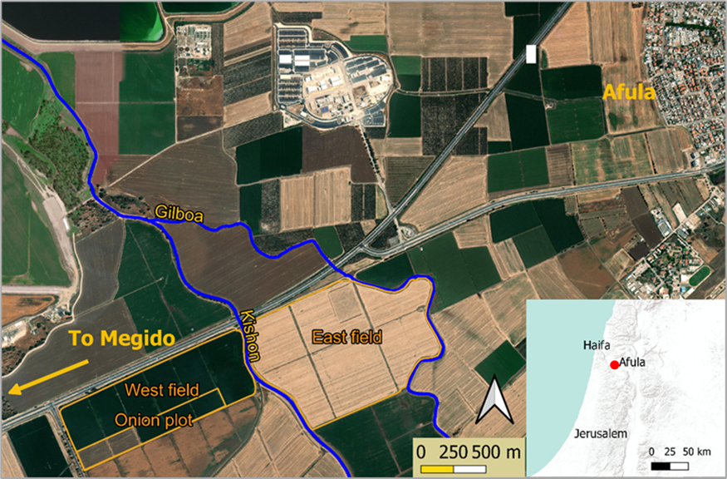

**Figure S1:** *The study area shows the East and West fields adjacent to the Kishon stream. The onion plot is located inside the West field. The map inset shows the regional location with the study area (red circle).*

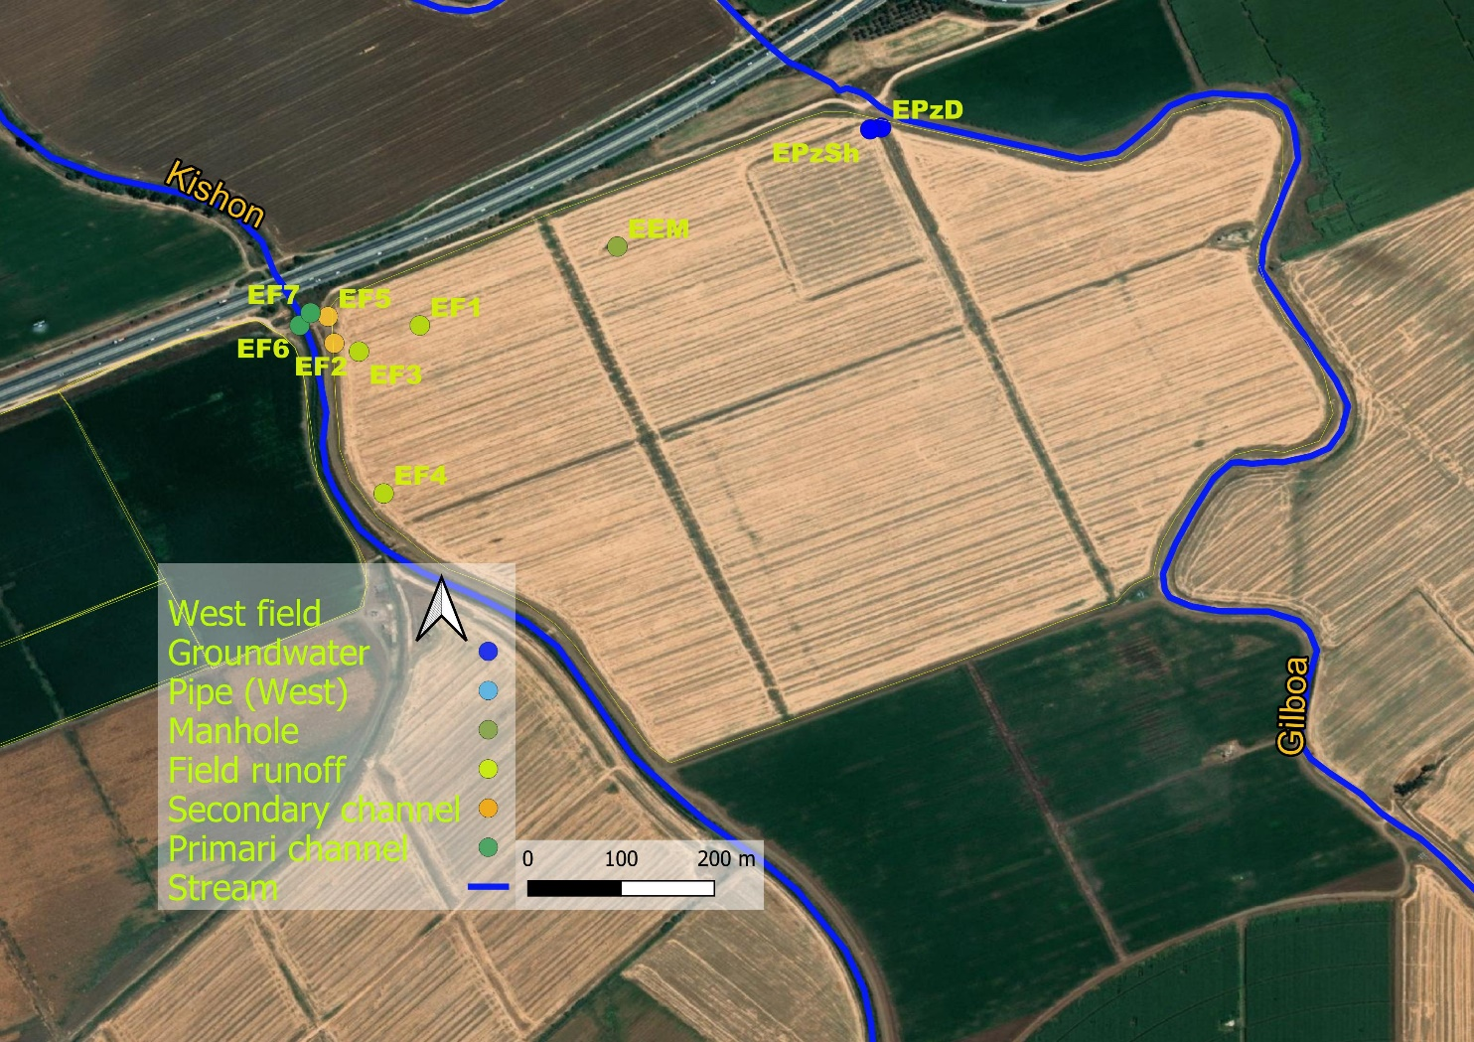

**Figure S2:** East field locations

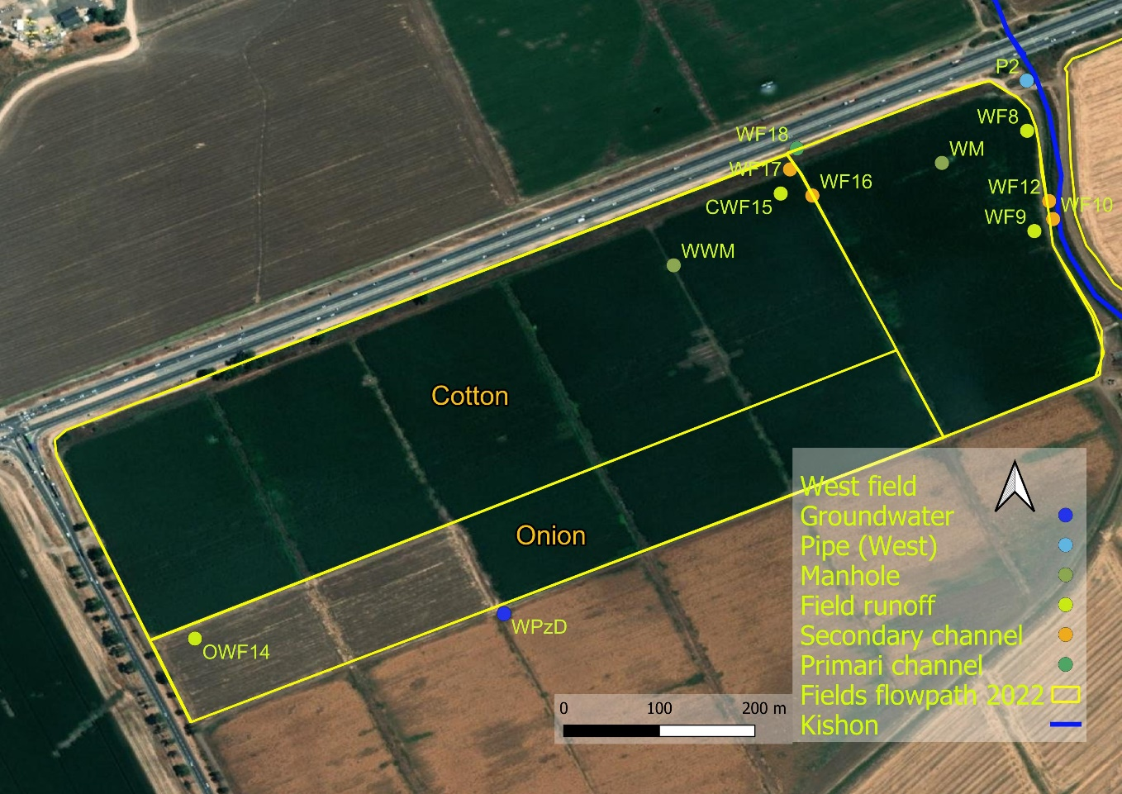

**Figure S3:** West field locations

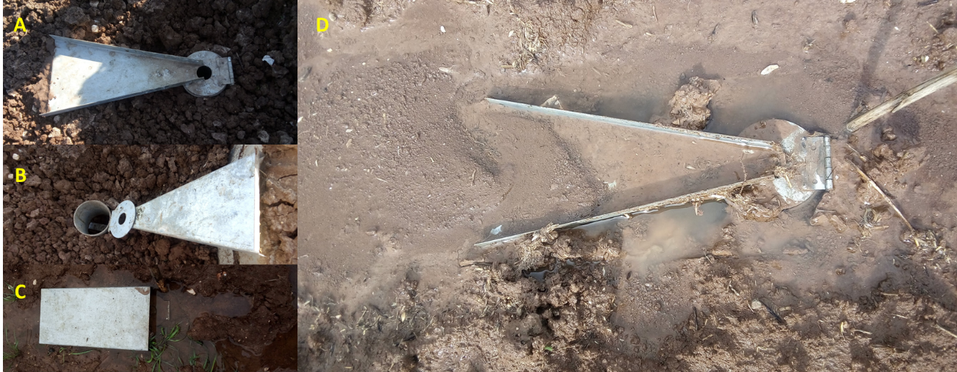

**Figure S4:** RCU (A) installed before rain; (B) RCU with flume open. The glass bottle is inserted into the designated cylindric space; (C) Ready for the storm, RCU with the roof protecting rain dilution; and (D) RCU after removing the roof to collect the full sample.

## Appendix B- Results

***Table S3:*** *This table defines the dominant flowpaths for each compound according to maximum detected concentrations (conc.). It also includes the highest concentration during the irrigation event on 28-29/4 in a separate category. The Farmers' application timing, including the last application date, is defined for 15 relevant compounds. ES/ED- East shallow/deep piezometers; WS, WD- West shallow/deep piezometers. n.d. -not detected. Bromacil, naproxen, and ibuprofen were added only in winter 2022 to the analyzed compounds. Where no application dates are available, it is assumed that the compound has not been applied since 2/2020 in the East field and as of 11/2012 in the West field.*

|  |  |  |  |  |  |
| --- | --- | --- | --- | --- | --- |
| **Name of organic compound** | **Max conc.**  **in winter 2022 (ng/L)**  **+ location** | **Max concentration in irrigation**  **(ng/L)** | **Concentration (ng/L) in groundwater+location** | **Date of last application by the farmer**  **(E-East field,**  **W-west field)** | **Number of samples in winter 2022 (of total 64)** |
| Acetaminophen* | 1308  2nd West manhole | n.d. | West piezometers only  17.34 WS |  | 9 |
| Acetamiprid | 1.5 West Primary channel | n.d. | West deep piezometer  0.39 | 16.6.2016 W | 11 |
| Ametryn | 1.27  West shallow piezometer | 1.49 | Deep and shallow East piezometers, Shallow West piezometer 1.37 WS | 14.6.2015 W | 18 |
| Atrazine | 31 West manhole | 219.07 | All piezometers  3.87 WD | 9.12.2020 W | 33 |
| Atrazinen desethyl | 127 West manhole | 623.37 | None |  | 20 |
| Atrazine desisopropyl | 86 West manhole | 312.16 | None |  | 17 |
| Azoxystrobin | 7.87 West field onion runoff | 2.4 | All piezometers  1.85 WD | 7.7.2019 W | 53 |
| Bezafibrate* | 21.6 East field runoff | n.d. | None |  | 4 |
| Boscalid | 302 East filed, West field onion runoff | 45.75 | All piezometers  17.31 WS |  | 50 |
| Bromacil | 46.5 West pipe outlet | n.d. | None |  | 11 |
| Caffeine | 2799 West field runoff | 1190 | All piezometers  620 ED |  | 35 |
| Carbamazepine* | 1421 West West manhole | 884.11 | All piezometers  119 ED |  | 63 |
| Carbamazepine 10,11n.d.epoxide | 305 West manhole | 175.91 | Shallow East piezometer, West deep piezometer 8.87 ES |  | 48 |
| Carbamazepine  2 hydroxy | 4.8 East field primary channel | 173.08 | None |  | 3 |
| Carbamazepine  trans- 10,11-dihidroxy | 68 2nd West Manhole | 173.08 | East shallow piezometer only 12.34 |  | 24 |
| Carbendazim | 14 West deep piezometer | 0.23 | All piezometers 13.95 WD |  | 38 |
| Carbofuran | 0.51 West deep piezometer | n.d. | West deep piezometer 0.51 |  | 1 |
| Chlorantraniliprole | 1475.7 Onion plot runoff | 539.01 | West deep piezometer 8.94 | 19.7.2019 W | 33 |
| Cyproconazole | 31.2 East field secondary channel | n.d. | None | 8.6.2018 W | 4 |
| Diazinon | 0.64 East deep piezometer | n.d. | East deep piezometer, West piezometers 0.64 ED |  | 9 |
| Diclofenac* | 12.72 West field secondary channel | n.d. | East shallow and West deep piezometers 3.58 WS |  | 5 |
| Difenoconazole | 17.12 West field runoff | n.d. | All piezometers  5.71 WS | 14.3.2018 W | 45 |
| Diflufenican | 6585 West field onion runoff | n.d. | All piezometers  0.65 ES, WS |  | 25 |
| Dimethomorph cis/trans | 6.17 East field secondary channel & West field deep piezometer | n.d. | West deep piezometer 6.17 |  | 7 |
| Diuron | 98996# East field runoff | 4.93 | All piezometers 123 ED | 17.2.19 W  30.12.21 E | 62 |
| Fenaminphos sulfoxide | 636 West field secondary channel | 1.43 | None |  | 25 |
| Fenaminphos | 28.2 West field primary channel | 12.65 | None |  | 4 |
| Fenhexamid | 19.8 2nd West Manhole | n.d. | None |  | 1 |
| Fluometuron | 12 Pipe outlet | 12.65 | Shallow East, deep West piezometers 3.16 ED |  | 21 |
| Flutriafol | 0.45  West shallow piezometer | 7.5  Ponding water | West deep piezometer 0.45 |  | 1 |
| Hexazinone | 1.2 West manhole | 1.55 | None |  | 4 |
| Ibuprofen* | 571.7 West pipe outlet | n.d. | None |  | 7 |
| Imidacloprid | 10621.2# West field onion runoff | 66.97 | All piezometers  15.28 ED, WD |  | 44 |
| Indaziflam | 1.21  East primary channel | n.d. | None |  | 2 |
| Lamotrigine* | 130  West manhole | 79.23 | East and West shallow piezometers 11.11 WS |  | 42 |
| Metalaxyl | 36.98 East field secondary channel | 7.2 | All piezometers  1.44 WD |  | 62 |
| Metazachlor | 7.65 West pipe outlet | n.d. | None |  | 1 |
| Methomyl | 3.91 West field onion runoff | n.d. | None |  | 1 |
| Methoxyfenozide | 971 2nd West manhole | 1379.8 | All piezometers  5.64 ES | 30.6.2020 W | 55 |
| Metolachlor | 92 West shallow piezometer | 40.24 | All piezometers  92 WS | 11.3.2020 W | 63 |
| Metribuzin | 8 Onion plot runoff | n.d. | 2.48 WD | 11.11.2019 W | 2 |
| Naproxen* | 5 East deep piezometer | n.d. | East deep piezometer 4.97 |  | 1 |
| Oxadiazon | 10808.9# West field onion runoff | n.d. | None | 10.1.2022 W | 13 |
| Penconazole | 5.8 East field secondary channel | 6.39 | East shallow, West deep, and shallow piezometers  2.92 WD |  | 16 |
| Pendimethalin | 11574# West field onion runoff | n.d. | All piezometer  1.15 WS | 20.2.16 W | 35 |
| Pirimicarb | (Only in irrigation) | 1.08 | None |  |  |
| Prochloraz | 0.5 Subsurface West pipe outlet | n.d. | None |  | 1 |
| Prometon | 0.4 West manhole | 0.58 | None |  | 3 |
| Prometryn | 1.52 Subsurface west pipe outlet | n.d. | West shallow piezometer  0.92 |  | 7 |
| Propachlor | 0.06 East shallow piezometer | n.d. | East shallow piezometer  0.06 |  | 1 |
| Propamocarb | 57.91 West deep piezometer | n.d. | All piezometer  57 WD |  | 63 |
| Propazine | (Only in irrigation) | 2.47 | None |  |  |
| Propiconazole | 7.3 East field runoff | n.d. | West shallow piezometer 1.85 |  | 2 |
| Propoxur | 367.3 West West manhole | 526.89 | All piezometers  22.59 ED |  | 43 |
| Propyzamide | 93.6 East field secondary channel | n.d. | West piezometers  15.24 WS | 12.2.2018 W | 17 |
| Sildenafil*,** | 139.96 West field primary channel | n.d. | East deep piezometer  21.16 |  | 3 |
| Simazine | 7.38 West deep piezometer | n.d. | West deep piezometers 7.38 |  |  |
| Sulfamethoxazole | 1.87 2nd West manhole | 17.34 | None |  | 1 |
| Sulfapyridine* | (Only in irrigation) | 0.59 |  |  |  |
| Tebuconazole | 42.5 West field onion runoff/East file secondary channel | 16.12 | All piezometers  18.54 WD | 11.5.2018 W | 51 |
| Tebuthiuron | 1.6 2nd West Manhole | 1.99 | None |  | 8 |
| Terbutryn | 79.15 West shallow piezometer | 10.23 | All piezometers  9.27 WS |  | 50 |
| Thiacloprid | 0.82 West field onion runoff | n.d. | None |  | 2 |
| Triadimenol A | (Only in irrigation) | 14.75, ponding water |  | 16.6.16 W | 0 |

# Measured concentrations were very high. Actual concentrations will be higher than reported; *- Pharmaceuticals (rather than pesticides); **- data contain significant errors for this compounds

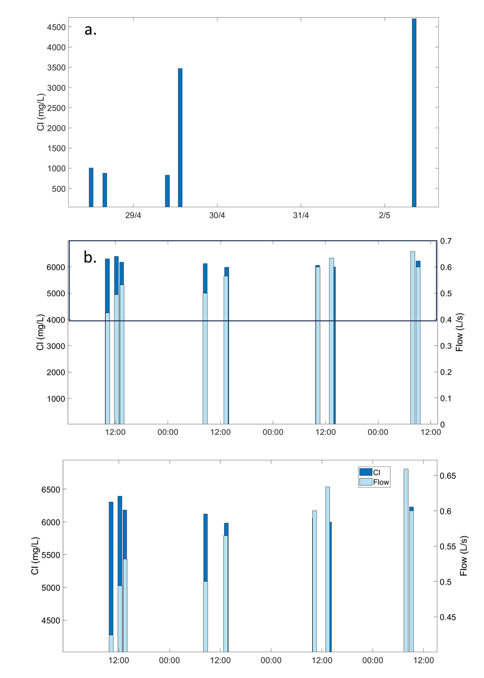

***Figure S5:*** *a. Chloride concentrations developed on the first irrigation event (April 2021). b.Chloride and water flow during irrigation since 20 June 2021 12:00 PM. c. Magnified enlarged black rectangle in b.*

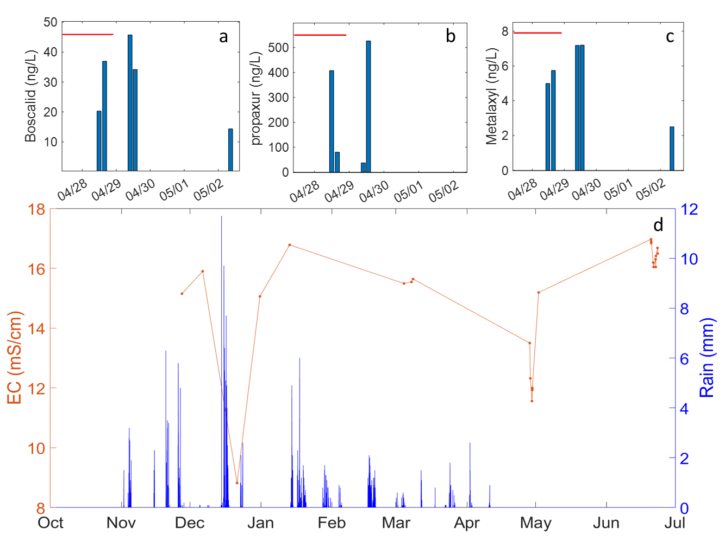

**Figure S6:** *a-c: Boscalid, propoxur, and metalaxyl concentrations (ng/L) during and after irrigation on April 28-29, 2021. The red bars stand for the duration of irrigation. d: Measured EC (mS/cm) during winter 2021 and spring 2021. The orange line illustrates the trend of EC, with markers indicating the times at which measurements were taken, while the blue bars represent rainfall. EC decline in irrigation is shown on 28/4-2/5 and 20-22/6.*

***Table S4:*** Application dates of analyzed compounds in the West field, ordered by first application date. Onion in parentheses states application in onion plot (contained carrot or tomatoes for some years)

|  |  |
| --- | --- |
| *West field* | dates |
| Diuron | 21/09/2015, 29/09/2015, 1/10/2015, 17/02/2019 |
| Ametryn | 14/06/2015 |
| Pendimethalin | 20/02/2016 (onion), 10/1/2022 (onion) |
| Propyzamide | 02/03/2016, 12/02/2018 |
| Acetamiprid | 22/05/2016, 16/06/2016 |
| Triadimenol | 16/06/2016 |
| Metolachlor | 12/02/2018, 11/03/2020 |
| Terbutryn | 15/01/2018 |
| Difenoconazole | 14/03/2018 |
| Chlorantraniliprole | 14/03/2018, 12/06/2019 (onion), 26/06/2019 (onion) |
| Tebuconazole | 11/05/2018 |
| Cyproconazole | 14/06/2018 |
| Methoxyfenozide | 23/05/2019, 30/06/2020 |
| Imidacloprid | 30/06/2019 (onion), 22/11/2022 (onion) |
| Azoxystrobin | 23/10/2019, 07/07/2019 |
| Metribuzin | 11/11/2019 |
| Atrazine | 09/12/2020 |
| Oxadiazon | 12/12/2021 (onion), 10/1/2022 (onion) |
| Diflufenican | 10/01/2022 (onion) |
| *East field* |  |
| Diuron | 30/12/2021 |

**Table S5:** Average concentrations in surface runoff and subsurface constituting the upper level water of subsurface and groundwater, respectively. Data measured in the West field: average over drainage channels and field surface runoff provide the runoff average concentration, and the average subsurface data by WM, Second WM and SP2-1 provide the subsurface average for storms. Standard deviation of each average is given in parenthesis. Koc values are from databases, where given, or average in a case given of range for Koc rather than a single value. n.d.- not detected.

|  |  |  |  |
| --- | --- | --- | --- |
|  | **Average surface runoff concentrations in West field (ng/L)** | **Average subsurface concentrations in West field (ng/L)** | **Koc values from databases (L/Kg)** |
| **Acetamiprid** | 1.05 (0.58) | n.d. | 200 |
| **Acetaminophen** | 6.66 (0) | 657.55 (650.53) | 21 |
| **Ametryn** | 0.51 (0) | 0.40 (0) | 316 |
| **Atrazine** | 9.10 (6.58) | 20.19 (11.01) | 100 |
| **Atrazine-**  **Desethyl** | 17.59 (9.59) | 68.48 (49.2) |  |
| **Atrazine-**  **Desisopropyl** | 26.78 (12.5) | 77.09 (9.38) |  |
| **Azoxystrobin** | 3.06 (2.12) | 0.91 (0.28) | 589 |
| **Boscalid** | 82.43 (59.2) | 53.69 (28.34) | 9500 |
| **Caffeine** | 52.95 (0) | 43.34 (4.04) | 4250 |
| **Carbamazepine** | 244.23 (217.4) | 942.52 (579.27) | 510 |
| **Carbamazepine-10,11-epoxide** | 45.94 (43.23) | 177.97 (119.05) | |  | | --- | |  | |  | |
| **Carbamazepine-trans-10,11-dihydroxy** | 17.22 (8.35) | 44.63 (26.37) |  |
| **Carbendazim** | 1.19 (0.32) | 0.33 (0) | 1463 |
| **Carbofuran** | n.d. | n.d. |  |
| **Chlorantraniliprole** | 218.71 (263.86) | 422.46 (292.45) | 362 |
| **Diclofenac** | 6.29 (4.04) | n.d. | 245 |
| **Difenoconazole** | 7.68 (4.2) | 4.30 (2.63) | 5467 |
| **Diflufenican** | 443.92 (907.79) | 52.89 (50.18) |  |
| **Dimethomorph** | n.d. | n.d. | 5690 |
| **Diuron** | 498.40 (745.93) | 257.47 (339.15) | 680 |
| **Fenhexamid** | n.d. | 19.79 (0) | 475 |
| **Fluometuron** | 6.64 (0) | 7.75 (4.24) | 100 |
| **Flutriafol** | n.d. | n.d. |  |
| **Imidacloprid** | 1860.17 (2921) | 970.71 (678.48) | 156-800 |
| **Lamotrigine** | 33.95 (27.09) | 74.67 (49.96) | 1900 |
| **Metalaxyl** | 10.32 (6.63) | 6.06 (3.25) | 162 |
| **Metazachlor** | n.d. | 7.65 (0) | 54 |
| **Methoxyfenozide** | 260.10 (261.79) | 593.09 (387.49) | 402 |
| **Metolachlor** | 11.86 (11.87) | 8.04 (5.94) | 120 |
| **Metribuzin** | 8.00 (0) | n.d. | 60 |
| **Naproxen** | n.d. | n.d. |  |
| **Oxadiazon** | 1683.02 (1874.11) | 247.43 (233.63) | 3200 |
| **Penoconazole** | 1.93 (1.62) | n.d. |  |
| **Pendimethalin** | 294.48 (644.25) | 13.16 (12.22) | 17491 |
| **Prometryn** | n.d. | 1.52 (0) | 400 |
| **Propochlor** | n.d. | n.d. | 80 |
| **Propamocarb** | 2.35 (1.96) | 3.34 (2.6) | 100 |
| **Propiconazole** | 3.53 (3.53) | n.d. | 1086 |
| **Propoxur** | 9.45 (1.44) | 200.31 (167.07) | 30 |
| **Sildenafil** | 139.66 (0) | n.d. | 27000 |
| **Simazine** | n.d. | n.d. | 130 |
| **Sulfamethoxazole** | n.d. | 1.86 (0.01) | 72 |
| **Tebuconazole** | 14.13 (13.2) | 5.09 (0.58) | 470-6000 |
| **Tebuthiuron** | n.d. | 1.36 (0.23) | 80 |
| **Terbutryn** | 4.46 (6.83) | 1.23 (0.43) | 2432 |
| **Bromacil** | 1.15 (0) | 43.60 (10.44) | 32 |

**Table S6: A summary of the groups according to trends of behavior in the groundwater**

|  |  |  |  |  |  |
| --- | --- | --- | --- | --- | --- |
| **Group name** | **Concentration in upper layer (subsurface water or runoff)** | **Concentration in soil water** | **Dominant processes at the beginning of the storm (before the storm peak)** | **Dominant processes at the end of the storm (after the storm peak)** | **Typical mobility of the compound member in the group** |
| Group 1 | Higher/similar | Relatively higher | Piston effect | Leaching. Macropores? | Low-intermediate |
| Group 2 (legacy pollutants) | Lower | Higher | Different processes/ piston | Different processes/ dilution | Mixed |
| Group 3 | Higher/similar | Lower | Dilution | Leaching. Macropores? | Mobile/highly immobile |
| Group 41 | Lower | Lower | Dilution | Dilution | Mobile/highly immobile |

1 *subgroup of 3rd group*

## Appendix C- discussion

### C.1 groundwater and subsurface water concentrations

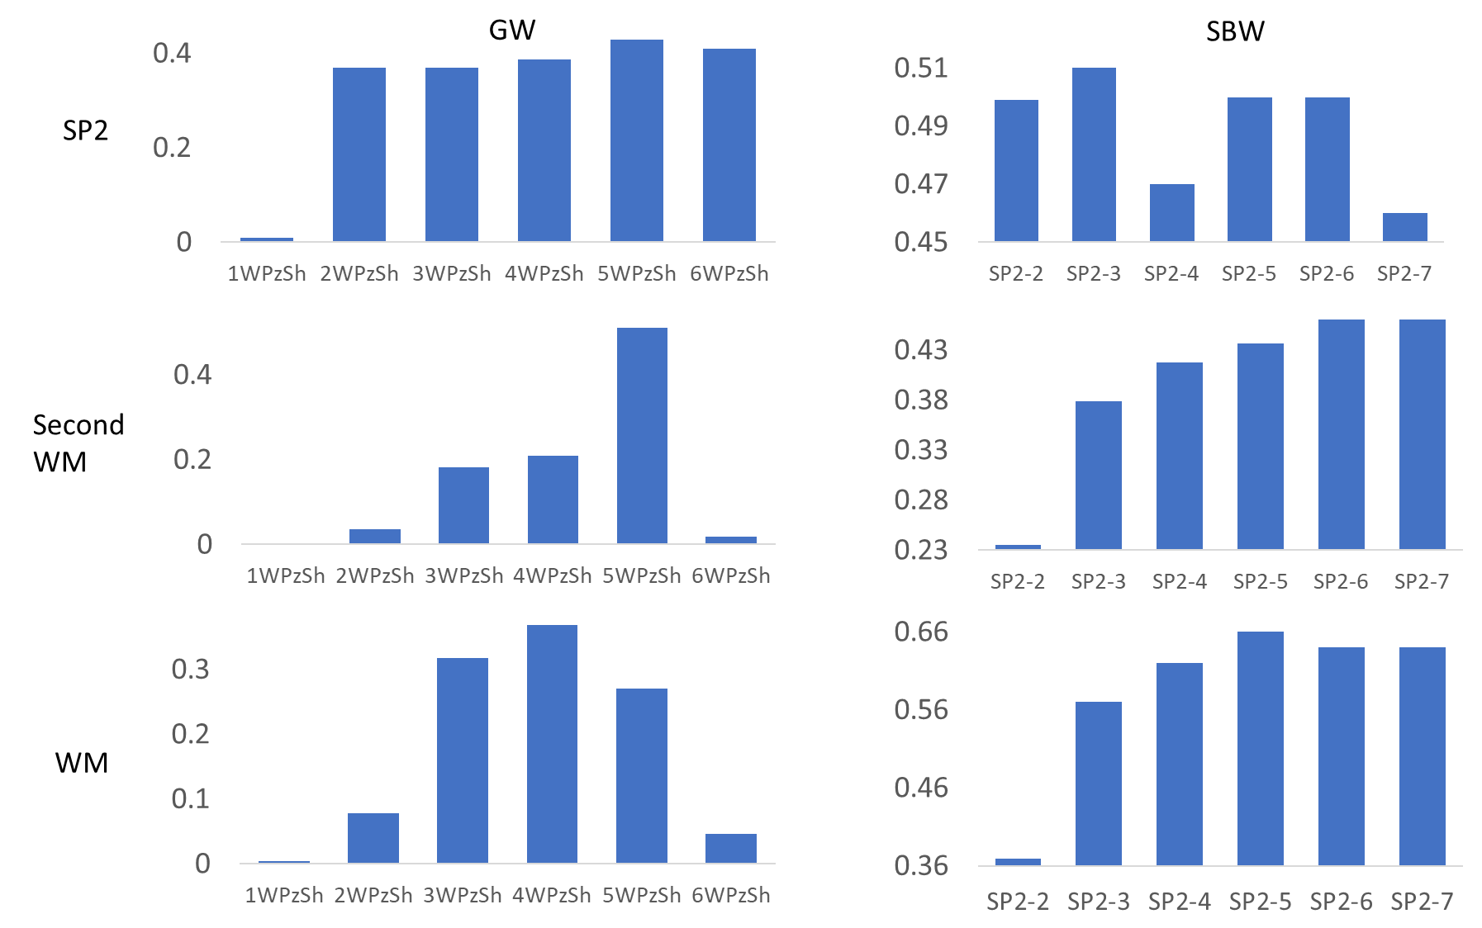

**Figure S7:** Bar plots of R2 values for linear accepted in plots of all compounds in two locations against eachother. R2 is for linear accepted plotting (top to bottom): SP2, Second WM, WM against each measurement in groundwater (left column) and subsurface water (right column). The closest in time and distance the measurement, the higher R2 are. For example: lowest R2 was accepted for Second WM against 1st data in groundwater time series. Highest R2 (0.66) was accepted for WM against SP2 4th sample in the time series. Highest values stand for SP2 series against WM (right bottom). WM was taken from manhole (subsurface related) at the last day of subsurface time series (sample SP2-7), 128 m from pipe outlet. This supports the groundwater and subsurface water to be distinct flowpaths.

### C.2 patterns in groundwater and subsurface time series

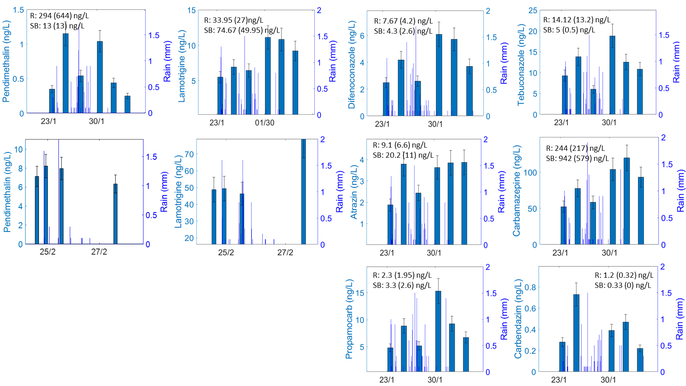

**Figure S8:** Time series of the several 1st group compounds detected in groundwater in West shallow piezometer (23 Jan-3 Feb 2022). Lamotrigine and pendimethalin include also subsurface time series (22-27 Feb 2022) that present similar pattern. Concentrations are given in dark blue bars, rain is given in thin lines. Typical behavior is observed in this group: the concentration increases with storm beginning, then dilutes in storm peak and afterwards concentration rise. Average subsurface concentration over 1st and 2nd storms (SB) for each material is provided, with standard deviation in parenthesis.

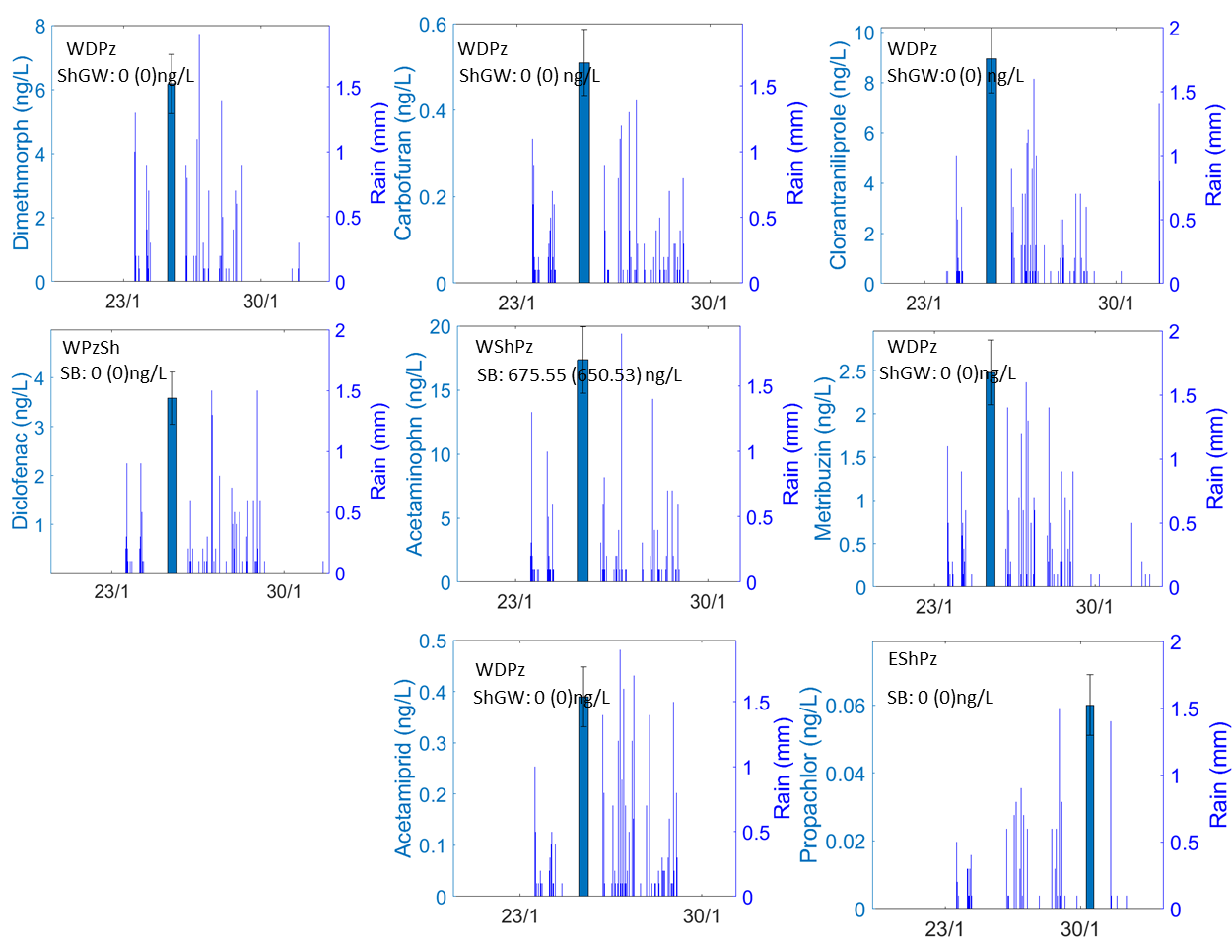

***Figure S9:*** *2nd group Legacy pollutants appeared in storm. Most compounds were not detected in the upper layers. The compounds were detected in deep groundwater of the West field (WDPz), shallow West field piezometer (WShPz) or shallow Eastfield piezometer (EShPz) during the storm. Propachlor was detected in the last days of the storm. SB is the average subsurface concentration. Standard deviation appears in parenthesis.*

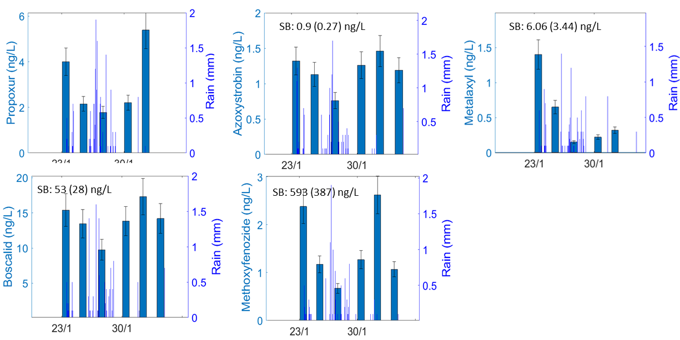

**Figure S10:** *3rd group: chemical concentrations decrease gradually with storm due to dilution in groundwater (Jan. 2022).* Concentraion rise occurred right after storm peak, assumably due to new water.

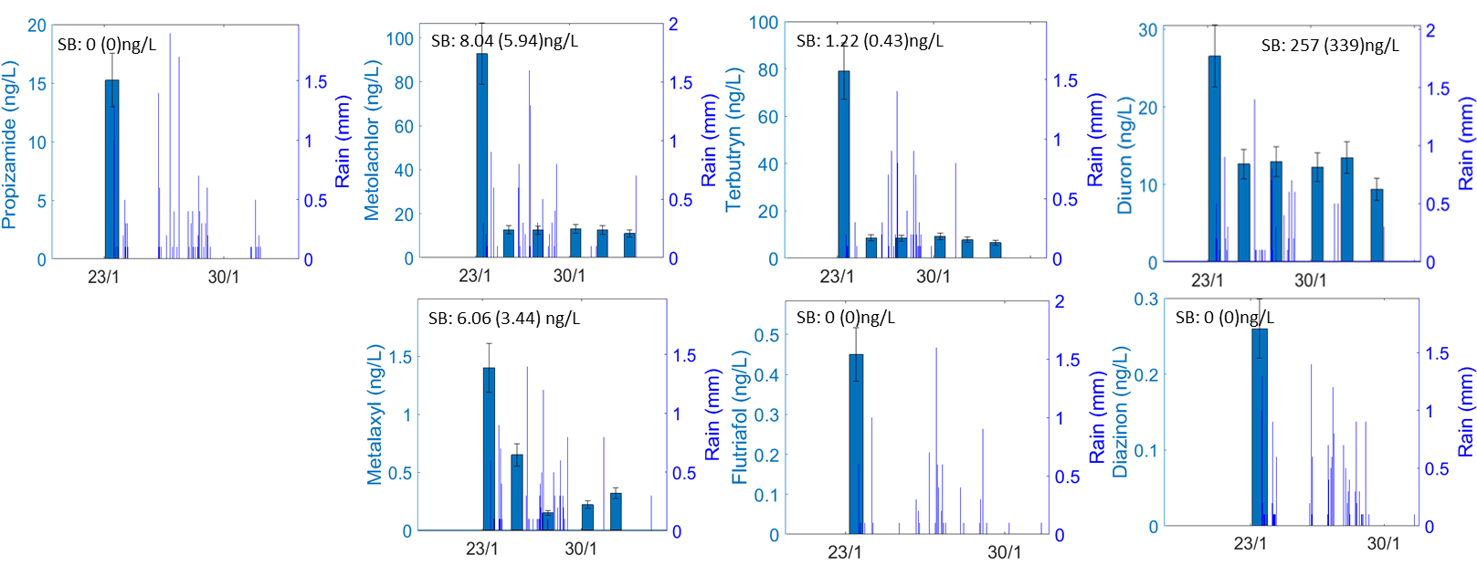

**Figure S11:** *4th group: Strong dilution of West field groundwater in a storm due to low concentration in upper layers and negligible concentration in soil water, leading to nonsignificant concentration rise by piston effect. For some compounds, the dilution reduced the concentration below the detection limit. After storm peak, and assumably due to low concentration for most compounds or very low mobility, water arrival with a lower concentration than groundwater results in keeping the dilution for the entire storm.*

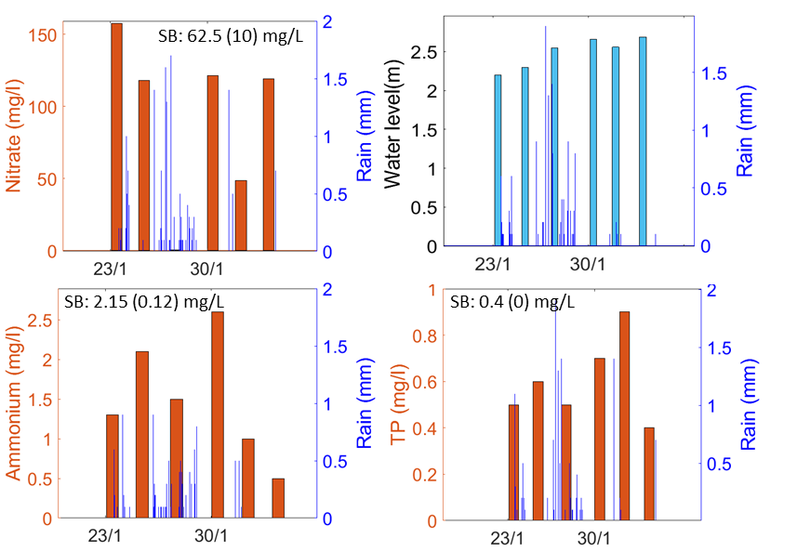

**Figure S12:** Nutrients (nitrate, ammonium and total phosphorus (TP) as measured in the West shallow piezometer. The nitrate and the TP are characteristic nutrients, represent mobile and less mobile molecules, respectively. The Nitrate behave more like the 3rd group, which was found to include more significantly mobile compounds and the TP behaves like compounds assumably more related to soil water and adsorption-desorption processes.

## Research data

(EXCEL- double click to open data)

